PLS-SEM Approach and Sentiment Analysis for Identifying Significant Factors of Customer Satisfaction

1st Marastika wicaksono aji bawono
Departement of Technology Management
Sepuluh Nopember Institute of Technology
Surabaya, East Java
7032221023@mhs.its.ac.id

2nd Diana Purwitasari
Departement of Informatics Engineering
Sepuluh Nopember Institute of Technology
Surabaya, East,Java
diana@if.its.ac.id

3rd Mauridhi Hery Purnomo
Departement of Electrical Engineering
Departement of Computer Engineering
Sepuluh Nopember Institute of Technology
Surabaya, East,Java
hery@ee.its.ac.id

Abstract — In the Digital Transformation 4.0 product reviews have a significant influence on E-Commerce companies. Each review will directly affect consumer satisfaction and will impact the brand image of the commercial entity in the market. The main indicators of a product are product quality, functionality and value, currently product reviews provide critical insights for consumers to make purchasing decisions for a product. The purpose of this paper is to dissect and analyze 775 negative comment reviews and 557 positive comment reviews taken from four E-Commerce platforms. This paper will classify reviews into positive and negative sentiments to determine the trend of reviews on e-commerce products. The methodology in this paper involves field observations of the online shopping experience of 254 E-Commerce customers. Data was collected through a questionnaire which was validated and analyzed using the Partial Least Squares Structural Equation Modeling (PLS-SEM) approach using the Lavalan R library in the R programming environment. The questionnaire resulted in a rating scale from 1 to 5 with the category "very satisfied" to "less satisfied" which effectively describes the positive comments and negative comments. The collected field commentary data will be processed and compared against the commentary data extracted from the four trading accounts on the market. Data will be analyzed using various analytical models including K-Nearest Neighbors (KNN), Multinomial Naive Bayes (MNB), Stochastic Gradient Descent (SGD), and Decision Trees (DT). The results of this paper reveal that the Naive Bayes method produces the highest accuracy in sentiment analysis with an accuracy value of 0.886. In addition, the analysis performed using R Programming shows that the e-commerce quality model produces the best R-Square value of 0.885. This paper also reveals various factors that influence service quality, which are represented by a coefficient value of 0.865 and a perceptual reputation score of 0.162.
Keywords — E-Commerce, Sentiment Analysis, Product Reviews, R Programming.

Introduction
In recent years e-commerce and online shopping platforms have seen a significant increase in popularity. Review impact results in a strong brand image and favourable product reviews. This trend is projected to continue as more consumers choose the convenience and ease of shopping online. As a result, e-commerce companies will rely more and more on product recommendation systems. This system provides a shopping experience according to individual tastes and interactions of each user on the e-commerce platform. This personal recommendation system has become an important instrument because it has an impact on the success of online retail businesses [1]. An important aspect of this system is the collection of user feedback through reviews. When users participate in reading and writing reviews, they can gain valuable insights from those reviews. Reviews can be used to make more informed purchasing decisions. Platforms that emphasize the importance of cultivating social relations and promoting user-generated opinions are identified as social recommendation systems. [2].
Recent studies have shed light on the concept that positive experiences are created when the perceived benefits outweigh the associated costs. This occurs when a person's perception of a product or service exceeds their initial expectations. This greatly influences subsequent actions including making purchases, repeat business, or providing that experience to others [3]. Social media platforms that function as promotional tools have a significant influence on customer purchase intentions. The instantaneous and diverse features of social commerce platforms enable personalized engagement and collaboration to increase consumer trust. This increase in trust is realized by providing value as perceived by the customer. [4]. The combination of e-commerce and social media significantly influences customer purchasing choices, especially through the integration of e-commerce product evaluation [5]. Previous studies have examined customer reviews shared in text form on digital platforms including: statuses, tweets, comments, and evaluations. The main evaluation metrics used include liking, usefulness, and satisfaction. Machine learning algorithms, including Logistic Regression (LR), Random Forest (RF), Decision Trees (DT), Nearest Neighbor (KNN), Support Vector Machine (SVM), Naive Bayes Multinomial (MNB), Stochastic Gradient Descent (SGD), and Boost has been used together with the Term Frequency-Inverse Document Frequency (TF-IDF) and Bag-of-Words (BoW) features [6]. Actual field observations related to consumer needs are rarely carried out.
This paper emphasizes the importance of uncovering facts based on insights from the field and market commentary data. The PLS-SEM (Partial Least Squares-Structural Equation Modelling) technique is used to dig deeper into the role of trust in the relationship between consumer engagement on social media and customer satisfaction [7].
The results show that a high level of trust in online retailers increases consumer purchase intentions and future repurchase intentions by reducing perceived risk [7]. Conversely, customer satisfaction can be explained as consumers' emotional reactions when comparing the perceived performance of products and services according to their initial expectations. Such comparisons can evoke feelings of pleasure or frustration, depending on the standard set by previous experience [8]. Within the scope of e-commerce, website security is a major concern [9]. Therefore, it is very important to carry out a survey to identify cyberthreat intelligence indicators that can impact customer satisfaction. Previous research is one of the first references to explore the challenges faced by social trading for entrepreneurs. The findings show that social media activity positively influences trust. In times of uncertainty, consumers often seek guidance and solutions on social media platforms. According to previous research, social media is an important element in forming trust [10].
Regarding the effectiveness of reviews it was found that certain negative comments about a product can have a strong effect on consumer perceptions [13]. Online reviews have been considered as a reliable resource for consumers when making purchases [14]. The perceived usefulness of the overall reviews as well as the individual product ratings within them have been shown to correlate with the quality of the information they hold [15].

RELATED WORK
Previous studies have used the Smart PLS tool to test contextual models using the Partial Least Squares Structural Equation Modeling (PLS-SEM) method. The current research builds on previous research using the PLS-SEM method to investigate indicators of perceived reputation influencing consumer satisfaction. These indicators include fast delivery, fast complaint resolution, prompt response to return or exchange requests, and polite behavior during the return or exchange process. However, sentiment analysis was not included in this study [3].
This study builds on previous research that investigated trust indicators along with service characteristic factors, basic service expectations, personalized service expectations, and social attributes. The novelty of this study lies in validating user comments directly, by comparing product comment data obtained through seller accounts at e-commerce companies [4]. This paper builds on previous research using the PLS-SEM method to evaluate service quality indicators that affect trust. Several factors, including certainty, empathy, responsiveness, and trust, were validated based on product comment data obtained from e-commerce companies [5].
In previous studies, the Naive Bayes classification was used to dissect consumer sentiment. Meanwhile, SVM is used to categorize user sentiment in binary form. Data preprocessing techniques such as Term Frequency (TF) and Inverse Document Frequency (IDF) are applied before providing data to the network model for feature assessment. The aim of this paper is to find out which machine learning methodology is statistically superior between SVM and Naive Bayes classification [9]. Initially, this paper uses the Naive Bayes classification to analyze consumer sentiment, while SVM is used to separate user sentiment into two categories. The data undergoes preprocessing using Term Frequency (TF) and Inverse Document Frequency (IDF) techniques, then is assessed by a network model for feature evaluation. The aim of this paper is to define a machine learning methodology which is statistically superior between the SVM and Naive Bayes classifications [16]. In the platform analysis domain previous research investigated the characteristics of the more than 1.2 million reviews written by more than 327,000 users on the Yelp Bay Area and Amazon platforms. The findings show that cohesive groups are essentially reviewers and the strongest predictor of review success is the author's historical track record [6].
Table 1 presents a summary of the questions asked during direct observation, which was facilitated through the use of a questionnaire to customers.

TABEL 1 QUESTION FOR RESPONDENTS
Perceived Reputation [3] | E-Service Quality [5] | E-Trust [4]
(Fast delivery)  Is the delivery of goods on e-commerce delivered quickly? | (Assurance)  Is there a guarantee regarding damaged, defective, and rejected item that does not meet expectations? | (Service characteristic)  Does e-commerce have service characteristics for service facilities for complaints of defective or inappropriate goods and service facilities for returning goods or money?
(Handling complaint fast)  Are product and service customer complaints handled quickly using a trouble ticket or customer service? | (Empathy)  Does the delivery party or the seller's account company in e-commerce have empathy when the item is damaged during purchase? | (Basic service)  Is the basic service used in accordance with problem-solving using service level guarantee method?
(Fast answering for refund or change)  Are customer complaints regarding refunds and changes to e-commerce accounts answered quickly? | (Tangible)  Does the item order match customer's expectations after receiving product? | (Personalized service)  Does E-Commerce personalize service based on categories such as the top ten VIP customer?
(Friendly when refund or change)  Do e-commerce sellers behave in a friendly manner when refunding or changing product pick-ups? | (Responsive)  Is there customer service complaint service that is very responsive in solving problems? | (Social attributes)  Do social media product reviews o affect the brand image of e-commerce sellers?
(Reliability)
Does any customer service have the reliability of troubleshooting to determine damaged or defective items?

Methodology
This paper adopts methods from previous studies but incorporates different sentiment analysis algorithms. The initial stage involved using a questionnaire to gather direct feedback and recommendations from customers [20]. The next stage includes collecting product comment data from seller accounts on e-commerce platforms such as: Tokopedia, Shopee, Lazada and Bukalapak. The final stage involves creating a dashboard to monitor the trend of negative and positive comments regarding consumer product reviews on sellers' accounts in the marketplace. The fourth stage involves checking the accuracy of the sentiment analysis results using algorithms such as: K-Nearest Neighbors (KNN), Multinomial Naive Bayes (MNB), Stochastic Gradient Descent (SGD), and Decision Tree (DT). This is done by observing the variations in the results of the analysis based on the accuracy of the sentiment analysis algorithm model. The following Figure.1 is a flowchart of the research
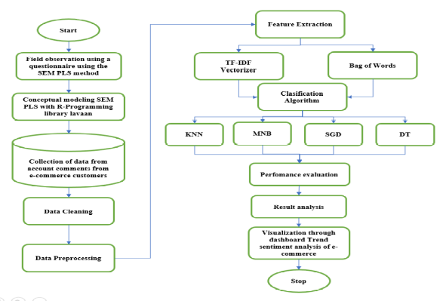

Figure 1. Flowchart methodology

A. Step 1 field observation with a questionnaire
PLS-SEM (Partial Least Squares-Structural Equation Modeling) is a powerful technique for causal modeling that aims to maximize the variance explained by the latent dependent variable using the predictors under investigation. An important initial step involves creating a diagram that depicts the relationship between the variables and explains the research hypothesis. Path diagrams are used to graphically depict theoretical and logical relationships between variables. It serves as a visual representation of the hypothesis being tested. This initial construction of the path model allows the organization of ideas to be more effective and visual. Thus, facilitating a thorough examination of the interrelationships between variables [21].
Therefore, it is very important to collect suggestions and feedback from customers regarding seller accounts in the market. This information is then processed using the PLS-SEM method, modeled in the R programming language with the help of the 'lavaan' library. Step 2 retrieve data from the top ten seller accounts of the e-commerce company. After identifying the keywords from the results of the questionnaire through the PLS-SEM method, sentiment classification was carried out to provide sentiment labels. Conducting large-scale sentiment analysis on user evaluations on e-commerce platforms will have the potential to increase user satisfaction [21]. The dataset used in this paper includes positive and negative feedback from seller accounts on various e-commerce platforms, particularly Tokopedia, Shopee, Lazada and Bukalapak.

Step 2 retrieve data from the top ten seller accounts of the e-commerce company.
The next stage involved analyzing trends in customer comments based on their purchasing experience to identify the most common negative and positive feedback from seller accounts at four e-commerce companies. A trending dashboard, which visualizes these positive and negative comments, was created using Google Colab. However, the distinguishing aspect of this process is the abandonment of the PLS-SEM method as a direct field observation tool for consumer product reviews [23]. Step 4 comparison of the most precise models in this stage, the accuracy of various models, namely K-Nearest Neighbors (KNN), Multinomial Naive Bayes (MNB), Stochastic Gradient Descent (SGD), and Decision Tree (DT), is evaluated to identify the model with the highest accuracy.

Step 3 classification of customer comment trends four e-commerce companies
The subsequent phase entailed analyzing customer comment trends based on their purchasing experiences to pinpoint the most prevalent negative and positive feedback from seller accounts at the four e-commerce companies. A trend dashboard, visualizing these positive and negative comments, was created using Google Colab. However, the distinctive aspect of this process was the exclusion of the PLS-SEM method as a direct field observation tool for consumer product reviews [23].

Step 4 comparison of the most precise models

In this phase, the accuracy of various models namely K-Nearest Neighbors (KNN), Multinomial Naive Bayes (MNB), Stochastic Gradient Descent (SGD), and Decision Tree (DT), were evaluated to identify the model with the highest accuracy.

Experimental result

Analysis of the model's overall quality with PLS-SEM

PLS-SEM, or Partial Least Squares-Structural Equation Modeling, is often considered exploratory in nature. This analysis not only has conceptual and practical similarities to multiple linear regression analysis in its aim to maximize the explained variance of the dependent variable but also involves assessing the quality of the measurement model. According to preliminary studies, PLS-SEM retains exploratory characteristics [24].
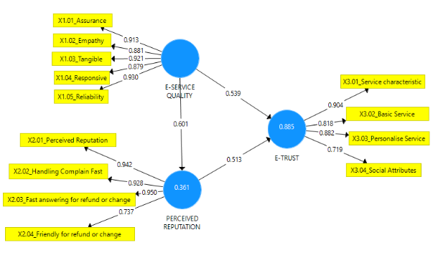

Figure 2. Theory Conceptual Model

Figure 2 presents the survey results obtained using the Smart PLS application. Selected component-based techniques were used to evaluate the structural model [25]. This application was chosen because of its capacity to manage both formative and reflective constructs with minimal requirements on sample size and distribution of residuals [26].

Evaluation

Analysis of structural equation modeling with library package lavaan use R Programming

The Lavaan module is a powerful open-source tool in R designed to support the analysis of multivariate models, including path analysis, confirmatory factor analysis, and structural equation modeling. The name "Lavaan" itself reflects its primary objective, which is to equip researchers with comprehensive tools for investigating, estimating, and comprehending diverse latent variable models. These models encompass a broad spectrum of techniques, such as factor analysis, structural equations, longitudinal analysis, stratified analysis, latent class analysis, item response theory, and methods for handling missing data.
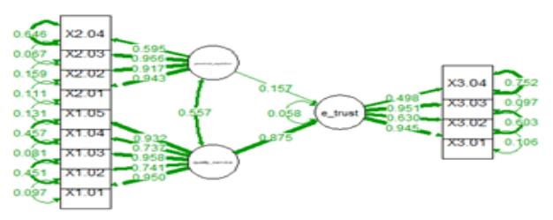

Figure 3. Model SEM PLS in library lavaan use R Programming

The PLS-SEM model, implemented in the Lavalan library, effectively describes the relationship between variables at the 0.05 significance level. This implementation was carried out using the R programming language which is presented visually in Figure 3. The innovation of this study lies in validating the sample model using R Programming along with creating a sentiment analysis dashboard to compare results as shown in Table 2.
TABLE 2 CROSS LOADING VALUE AND R SQUARE
Indicator | Cronbach  Alpha (>0.7) | rho_a  (>0.7) | Composite  Reliability  (>0.7) | Average  Variance  (>0.5) | R Square Adjusted
E-Service Quality | 0.945 | 0.948 | 0.958 | 0,819 | 0.885
Perceived Reputation | 0.851 | 0.863 | 0.901 | 0.695 | 0.858
E-Trust | 0.912 | 0.918 | 0.940 | 0.799 | 0.751
Comparison of the measurement results between the weights examined in Table 2 shows that the PLS SEM model is able to demonstrate conformity with the concept of composite reliability, also known as rho_a. This measure of composite reliability provides insight into scale dependence by measuring the degree to which factors contribute to the variance in the composite. In contrast, Cronbach's Alpha evaluates internal consistency and relationships between items on a scale. Cronbach's alpha offers a different perspective on scale reliability and connectedness. Composite reliability is calculated by calculating the average of the squared difference between each data point and the mean, and providing a measure of variance. This variance represents the total variance of the composite. On the other hand, adjusted R-squared modified version of R-squared considering the number of predictors used in the model. Taking into account the number of predictors adjusted R-squared provides a more accurate evaluation of the model's explanatory power. Adjusted R-squared considers the relative contribution of predictors by dividing the total variance against the factor variance and considering the number of predictors involved. This adjustment allows for a more accurate assessment of the model's explanatory power taking into account the complexity and number of predictors used.
The R-squared (R2) value serves as a measure of scale dependence to indicate the extent to which variation in an exogenous variable can be explained by one or several factors. R2 values greater than 0.75 are generally considered significant, while values between 0.50 and 0.75 indicate moderate level of significance. On the other hand, a value below 0.25 is considered weak or insignificant. From the evaluation of the R Square results presented above, it can be seen that the value of 0.885 exceeds the threshold of 0.75, so this value indicates a substantial level of significance. Therefore, the electronic service quality indicator shows a significant impact as indicated by the highest value of 0.885. In addition, the value of the electronic service quality indicator of 0.945, perceived reputation of 0.851, and electronic trust of 0.912 exceeds the threshold of 0.7 for Cronbach's alpha. The data show very good reliability for the questionnaire items. For each indicator the composite reliability value rho_a exceeds the threshold of 0.7 which can strengthen the quality of the model.

TABLE 3 THE MODEL FIT SUMMARY
 | Saturated Model | Estimated Model
SRMR | 0.125 | 0.125
d_ULS | 1.430 | 1.430
d_G | 2.122 | 2.122
Chi-Square | 2085.736 | 2085.736
NFI | 0.600 | 0.600
Rms Theta | 0.360 | 0.360
The model's adequacy was assessed using the results presented in Table 3, which includes the Root Mean Square Theta (RMS Theta) value of 0.360, accompanied by a standard deviation of 0.102. These values serve as crucial criteria for evaluating the fit of the model.
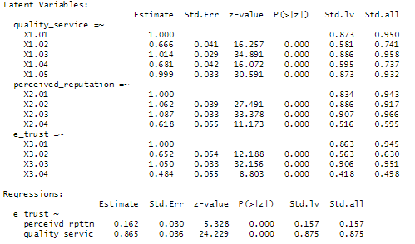

Figure 4. The results of R programming using the Lavaan library

The results depicted in Figure 4 demonstrate that each variable possesses a corresponding P(>|z|) or p-value below 0.05. This finding implies that every specific latent variable holds substantial influence over the latent dependent variable.
Notably, each independent latent variable presents a p-value below 0.05, indicating its significant impact on shaping the performance of e-trust.

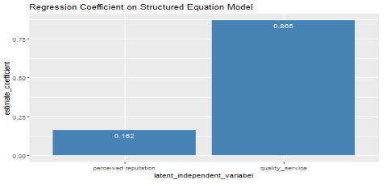

Figure 5 Regression coefficient on the structured equation model
Figure 5 reveals that service quality exerts the most significant influence, as evidenced by the estimated coefficient value of 0.865. Perceived reputation follows closely with a coefficient of 0.162. These results, obtained through the utilization of R Programming, provide further confirmation of the substantial impact that service quality and perceived reputation have on the model.

Method KNN, MNB, SGD, and DT
Sentiment analysis involves discerning whether a given text conveys a positive or negative sentiment. This paper develop a sentiment analysis methodology capable of predicting the sentiment expressed in comments on popular e-commerce platforms like Bukalapak, Tokopedia, Shopee, and Lazada. /
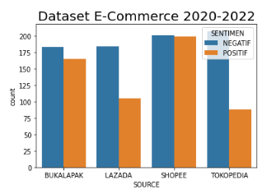

Figure 6. Data Visualization Dataset E-Commerce 2020-2022
Based on the data presented in Figure 6, the trend chart shows an increase in both positive and negative product review comments. This trend can be directly attributed to the influence of e-service quality and perceived reputation and will have a significant impact on the level of e-trust regarding e-commerce seller accounts from 2020 to 2022. The prediction process can use various algorithms including KNN, MNB, SGD, and DT. Algorithms can be used to predict outcomes and make predictions based on available data.
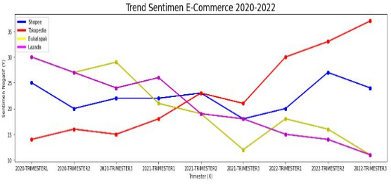

Figure 7. Trend Sentiment E-Commerce 2020-2022
The data in Figure 7 above is a report that displays trending sentiment analysis graphs. The graph shows an increase in negative comments about seller products related to the Tokopedia company.
​TABEL 4 ACCURACY KNN, MNB, GRADIENT DESCENT AND DT
 | K-Nearest  Neighbor | MNaive  Bayes | Sgradient  Descent | Decision  Tree
Accuracy | 0.850 | 0.886 | 0.863 | 0.749
Precision | 0.782 | 0.926 | 0.857 | 0.705
Recall | 0.887 | 0.789 | 0.807 | 0.686
f1_Score | 0.831 | 0.523 | 0.831 | 0.695
Table 4 displays a classification report that provides a comparison of the implemented algorithms. The accuracy values obtained for KNN, MNB, SGD, and DT are 0.849, 0.855, 0.863 and 0.748. The results can be concluded that the MNB algorithm achieves the highest accuracy among the algorithms tested. This comprehensive evaluation allows in-depth comparisons to be made to improve improvements throughout the analysis process.

Conclusion
The conclusion of this paper focuses on analyzing e-commerce seller sentiment using the Comparison Model algorithm. The results of this paper show that the MNB model has the highest accuracy of 0.886. The SGD model has an accuracy value of 0.863. The KNN model has an accuracy value of 0.850 and DT has an accuracy value of 0.749. The results of the structural equation model highlight the significant impact of service quality 0.865 and on perceived reputation which has a value of 0.162. The regression coefficient indicates the strength and direction of the relationship between these variables. Substantial influence of service quality in shaping reputation perceptions of value. For future research, it is suggested to analyze and develop a model to assess the extent of influence of social media on product brands in the context of e-commerce.

References
[1] Davoudi, Anahita, and Mainak Chatterjee. "Social trust model for rating prediction in recommender systems: Effects of similarity, centrality, and social ties." Online Social Networks and Media 7, 2018.
[2] Ye, Li, Chunming Wu, and Min Li. "Collaborative filtering recommendation based on trust model with fused similar factor." MATEC Web of Conferences. Vol. 139. EDP Sciences, 2017.
[3] Ruimei, Wang, et al. "Customers e-trust for online retailers: A case in China." 2012 Eighth International Conference on Computational Intelligence and Security. IEEE, 2012.
[4] Ramanathan, Usha, et al. "A new perspective of e-trust in the era of social media: insights from customer satisfaction data." IEEE Transactions on Engineering Management 69.4, 2020
[5] Liu, Pu, et al. "The effects of social commerce environmental characteristics on customers’ purchase intentions: The chain mediating effect of customer-to-customer interaction and customer-perceived value." Electronic Commerce Research and Applications 48 , 2021.
[6] Mamun, Md Mashiur Rahaman, Omar Sharif, and Mohammed Moshiul Hoque. "Classification of textual sentiment using ensemble technique." SN Computer Science 3.1, 2022.
[7] Chen, Jun, and Xiao-Liang Shen. "Consumers' decisions in social commerce context: An empirical investigation." Decision Support Systems 79, 2015.

[8] Smith, Sharon. "Influence of trust and delivery system on customer satisfaction and company performance on social commerce sites." Journal of Marketing Thought 3.4, 2017
.[9] Al-Khayyal, Ahlam, et al. "The impact of electronic service quality dimensions on customers’e-shopping and e-loyalty via the impact of e-satisfaction and e-trust: A qualitative approach." International Journal of Innovation, Creativity and Change 14.9, 2020.
[10] Kim, Angella Jiyoung, and Eunju Ko. "Impacts of luxury fashion brand’s social media marketing on customer relationship and purchase intention." Journal of Global fashion marketing 1.3, 2010.
[11] Zhang, Shuai, et al. "A deep bi-directional prediction model for live streaming recommendation." Information Processing & Management 58.2, 2021.
[12] Islek, Irem, and Sule Gunduz Oguducu. "A hierarchical recommendation system for E-commerce using online user reviews." Electronic Commerce Research and Applications 52, 2022.
[13] Floyd, Kristopher, et al. "How online product reviews affect retail sales: A meta-analysis." Journal of retailing 90.2, 2014.
[14] Filieri, Raffaele. "What makes online reviews helpful? A diagnosticity-adoption framework to explain informational and normative influences in e-WOM." Journal of business research 68.6, 2015.
[15] Asadabadi, Mehdi Rajabi, et al. "Enhancing the analysisof online product reviews to support product improvement: integrating text mining with quality function deployment." Journal of Enterprise Information Management 36.1, 2023,
[16] Dey, Sanjay, et al. "A comparative study of support vector machine and Naive Bayes classifier for sentiment analysis on Amazon product reviews." 2020 International Conference on Contemporary Computing and Applications (IC3A). IEEE, 2020
[17] Zhang, Kunpeng, et al. "SES: Sentiment elicitation system for social media data." 2011 IEEE 11th international conference on data mining workshops. IEEE, 2011..
[18]Xia, Rui, Chengqing Zong, and Shoushan Li. "Ensemble of feature sets and classification algorithms for sentiment classification." Information sciences 181.6 ,2011.
[19] Agarwal, Apoorv, et al. "Sentiment analysis of twitter data." Proceedings of the workshop on language in social media (LSM 2011), 2011.
[20] Gupta, Ansh, Aryan Rastogi, and Avita Katal. "A Comparative Study of Amazon Product Reviews Using Sentiment Analysis." 2021 International Conference on Advances in Computing, Communication, and Control (ICAC3). IEEE, 2021.
[21]Henseler, Jörg, Christian M. Ringle, and Rudolf R. Sinkovics. "The use of partial least squares path modeling in international marketing." New challenges to international marketing. Emerald Group Publishing Limited, 2009.
[22]Yang, Li, et al. "Sentiment analysis for E-commerce product reviews in Chinese based on sentiment lexicon and deep learning." IEEE access 8, 2020.
[23] Singla, Zeenia, Sukhchandan Randhawa, and Sushma Jain. "Statistical and sentiment analysis of consumer product reviews." 2017 8th International Conference on Computing, Communication and Networking Technologies (ICCCNT). IEEE, 2017.
[24] Henseler, Jörg, Geoffrey Hubona, and Pauline Ash Ray. "Using PLS path modeling in new technology research: updated guidelines." Industrial management & data systems, 2016.
[25] Hair Jr, Joseph F., et al. Advanced issues in partial least squares structural equation modeling. saGe publications, 2017.
[26] Ab Hamid, M. R., Waqas Sami, and MH Mohmad Sidek. "Discriminant validity assessment: Use of Fornell & Larcker criterion versus HTMT criterion." Journal of Physics: Conference Series. Vol. 890. No. 1. IOP Publishing, 2017.
[27] Hair, Joe F., Christian M. Ringle, and Marko Sarstedt. "PLS-SEM: Indeed a silver bullet." Journal of Marketing theory and Practice 19.2, 2011.
[28] Uzir, Md Uzir Hossain, et al. "The effects of service quality, perceived value and trust in home delivery service personnel on customer satisfaction: Evidence from a developing country." Journal of Retailing and Consumer Services 63, 2021.
[29] Uzir, Md Uzir Hossain, et al. "The effects of service quality, perceived value and trust in home delivery service personnel on customer satisfaction: Evidence from a developing country." Journal of Retailing and Consumer Services 63, 2021.
[30] Singla, Zeenia, Sukhchandan Randhawa, and Sushma Jain. "Statistical and sentiment analysis of consumer product reviews." 2017 8th International Conference on Computing, Communication and Networking Technologies (ICCCNT). IEEE, 2017.
[31] Gio, Prana Ugiana. Partial Least Squares Structural Equation Modeling (PLS-SEM) dengan Software SmartPLS. Uwais Inspirasi Indonesia, 2022.
[32] Gorriz, Juan-Manuel, et al. "A connection between pattern classification by machine learning and statistical inference with the General Linear Model." IEEE Journal of Biomedical and Health Informatics 26.11, 2021.
[33] Portet, Stéphanie. "A primer on model selection using the Akaike Information Criterion." Infectious Disease Modelling 5, 2020.
[34] Kubara, Maria, and Katarzyna Kopczewska. "Akaike information criterion in choosing the optimal k-nearest neighbours of the spatial weight matrix." Spatial Economic Analysis, 2023.
[35] Hair Jr, Joe F., Matt C. Howard, and Christian Nitzl. "Assessing measurement model quality in PLS-SEM using confirmatory composite analysis." Journal of Business Research 109,2020.
[36] Rahat, Abdul Mohaimin, Abdul Kahir, and Abu Kaisar Mohammad Masum. "Comparison of Naive Bayes and SVM Algorithm based on sentiment analysis using review dataset." 2019 8th International Conference System Modeling and Advancement in Research Trends (SMART). IEEE, 2019.
[37] Amin, Muhammad, Muhammad Nauman Akram, and Muhammad Amanullah. "On the James-Stein estimator for the Poisson regression model." Communications in Statistics-Simulation and Computation 51.10, 2022
[38]Shirazi, Farid, et al. "The importance of trust for electronic commerce satisfaction: an entrepreneurial perspective." British Food Journal 123.2, 2021.
[39]Al-Khayyal, Ahlam, et al. "The impact of electronic service quality dimensions on customers’e-shopping and e-loyalty via the impact of e-satisfaction and e-trust: A qualitative approach." International Journal of Innovation, Creativity and Change 14.9, 2020.
[40]Henseler, Jörg, Geoffrey Hubona, and Pauline Ash Ray. "Using PLS path modeling in new technology research: updated guidelines." Industrial management & data systems, 2016.
[41]Liu, Chao, Zheshi Bao, and Chuiyong Zheng. "Exploring consumers’ purchase intention in social commerce: An empirical study based on trust, argument quality, and social presence." Asia Pacific Journal of Marketing and Logistics, 2019
[42] Hsu, Meng-Hsiang, Chun-Ming Chang, and Li-Wen Chuang. "Understanding the determinants of online repeat purchase intention and moderating role of habit: The case of online group-buying in Taiwan." International Journal of Information Management 35.1 , 2015.

